AI LAB ASSIGNMENT-4.1

NAME : N.KEERTHI REDDY

ROLL NO.: 2403A52376

BATCH NO.:14

COURSE NAME: AI ASSISTED CODING

**Task #1 – Zero-Shot Prompting with Conditional Validation**

Objective

Use zero-shot prompting to instruct an AI tool to generate a function that validates an Indian mobile number.

Requirements

* The function must ensure the mobile number:
  + Starts with 6, 7, 8, or 9
  + Contains exactly 10 digits

Code:

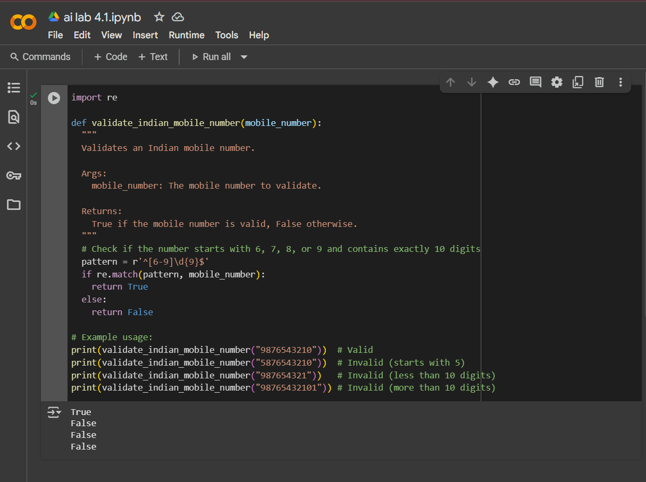

**Task #2 – One-Shot Prompting with Edge Case Handling**

Objective

Use one-shot prompting to generate a Python function that calculates the factorial of a number.

Requirements

* Provide one sample input-output pair in the prompt to guide the AI.
* The function should handle:
  + 0! correctly
  + Negative input by returning an appropriate message

Code:

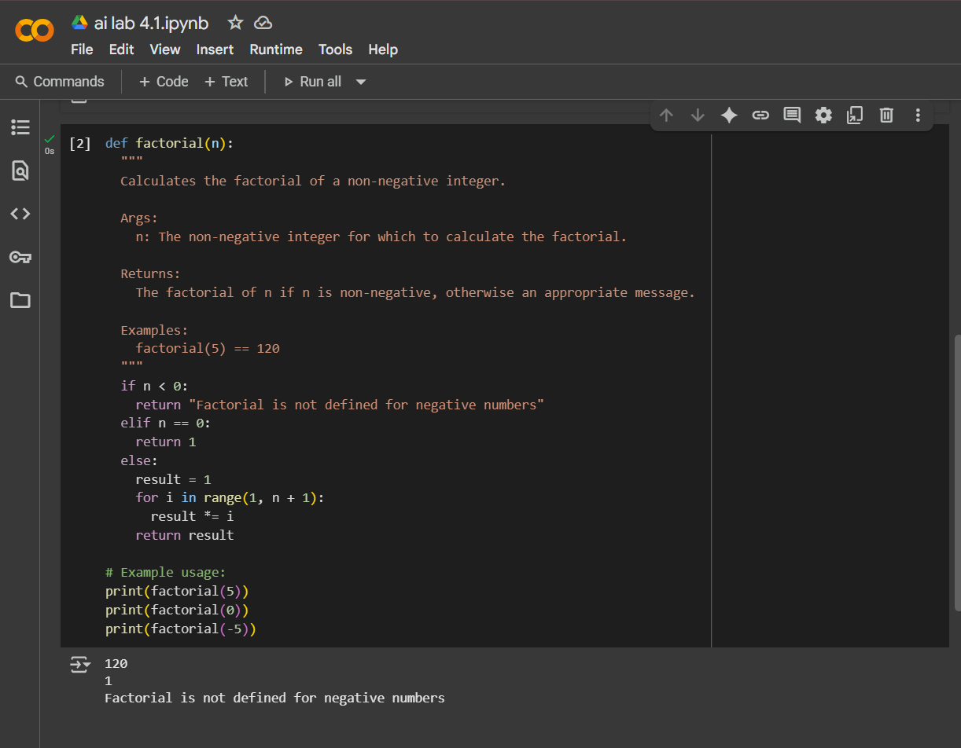

**Task #3 – Few-Shot Prompting for Nested Dictionary Extraction**

Objective

Use few-shot prompting (2–3 examples) to instruct the AI to create a function that parses a nested dictionary representing student information.

Requirements

* The function should extract and return:
  + Full Name
  + Branch
  + SGPA

CODE:

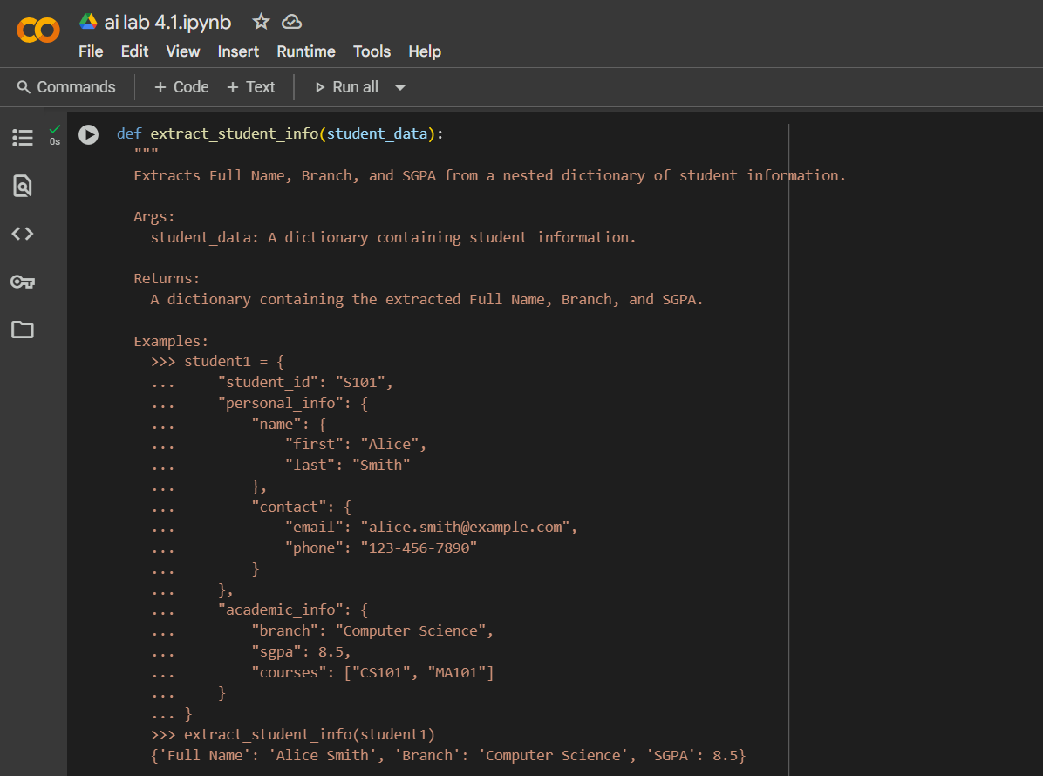

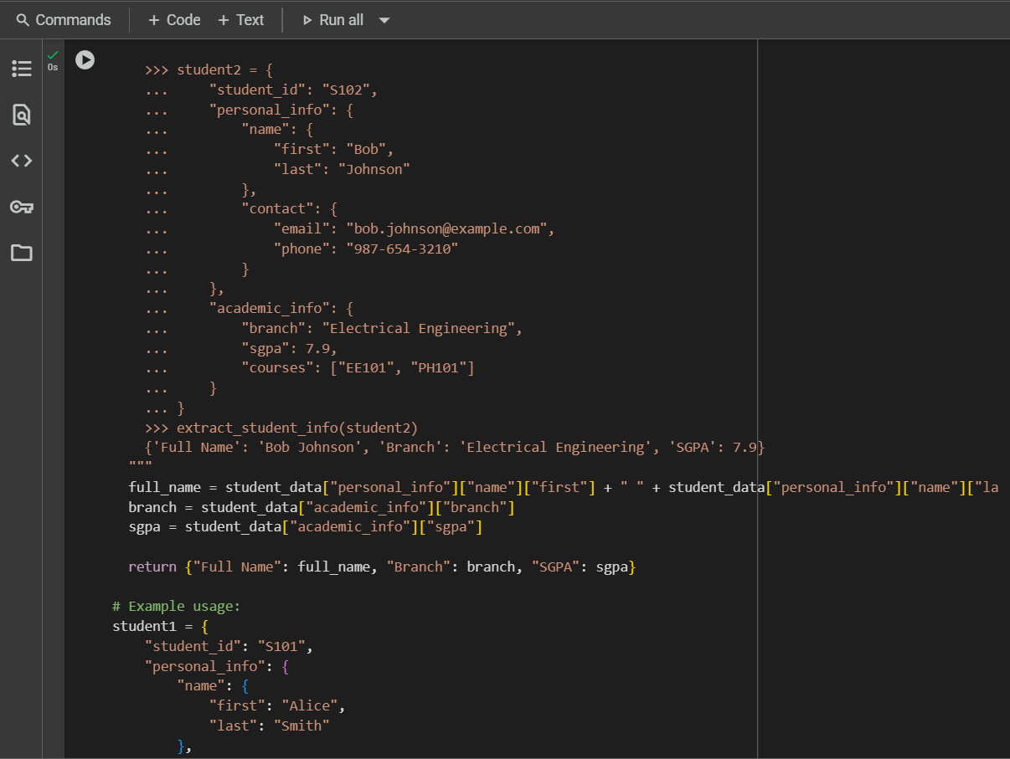

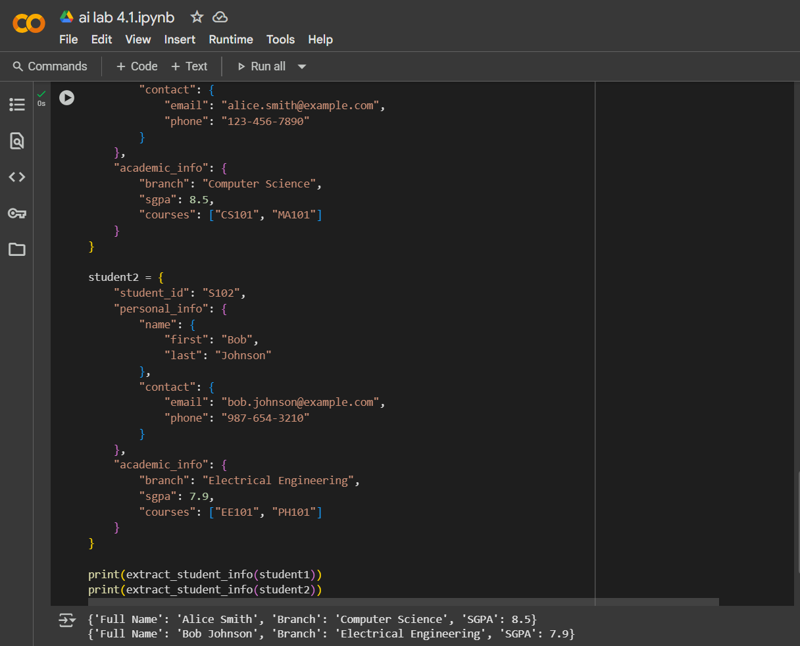

**Task #5 – Few-Shot Prompting for Text Processing and Word Frequency**

**Objective**

**Use few-shot prompting (with at least 3 examples) to generate a Python function that processes text and analyzes word frequency.**

**Requirements**

**The function must:**

* **Accept a paragraph as input**
* **Convert all text to lowercase**
* **Remove punctuation**
* **Return the most frequently used word**

Code:

